# TECHNICAL DEVELOPMENT CENTRE

# TECHNICAL DEVELOPMENT CENTER

# Automatic feeder for aquarium fish

# «DOMOVOY»

# User Manual

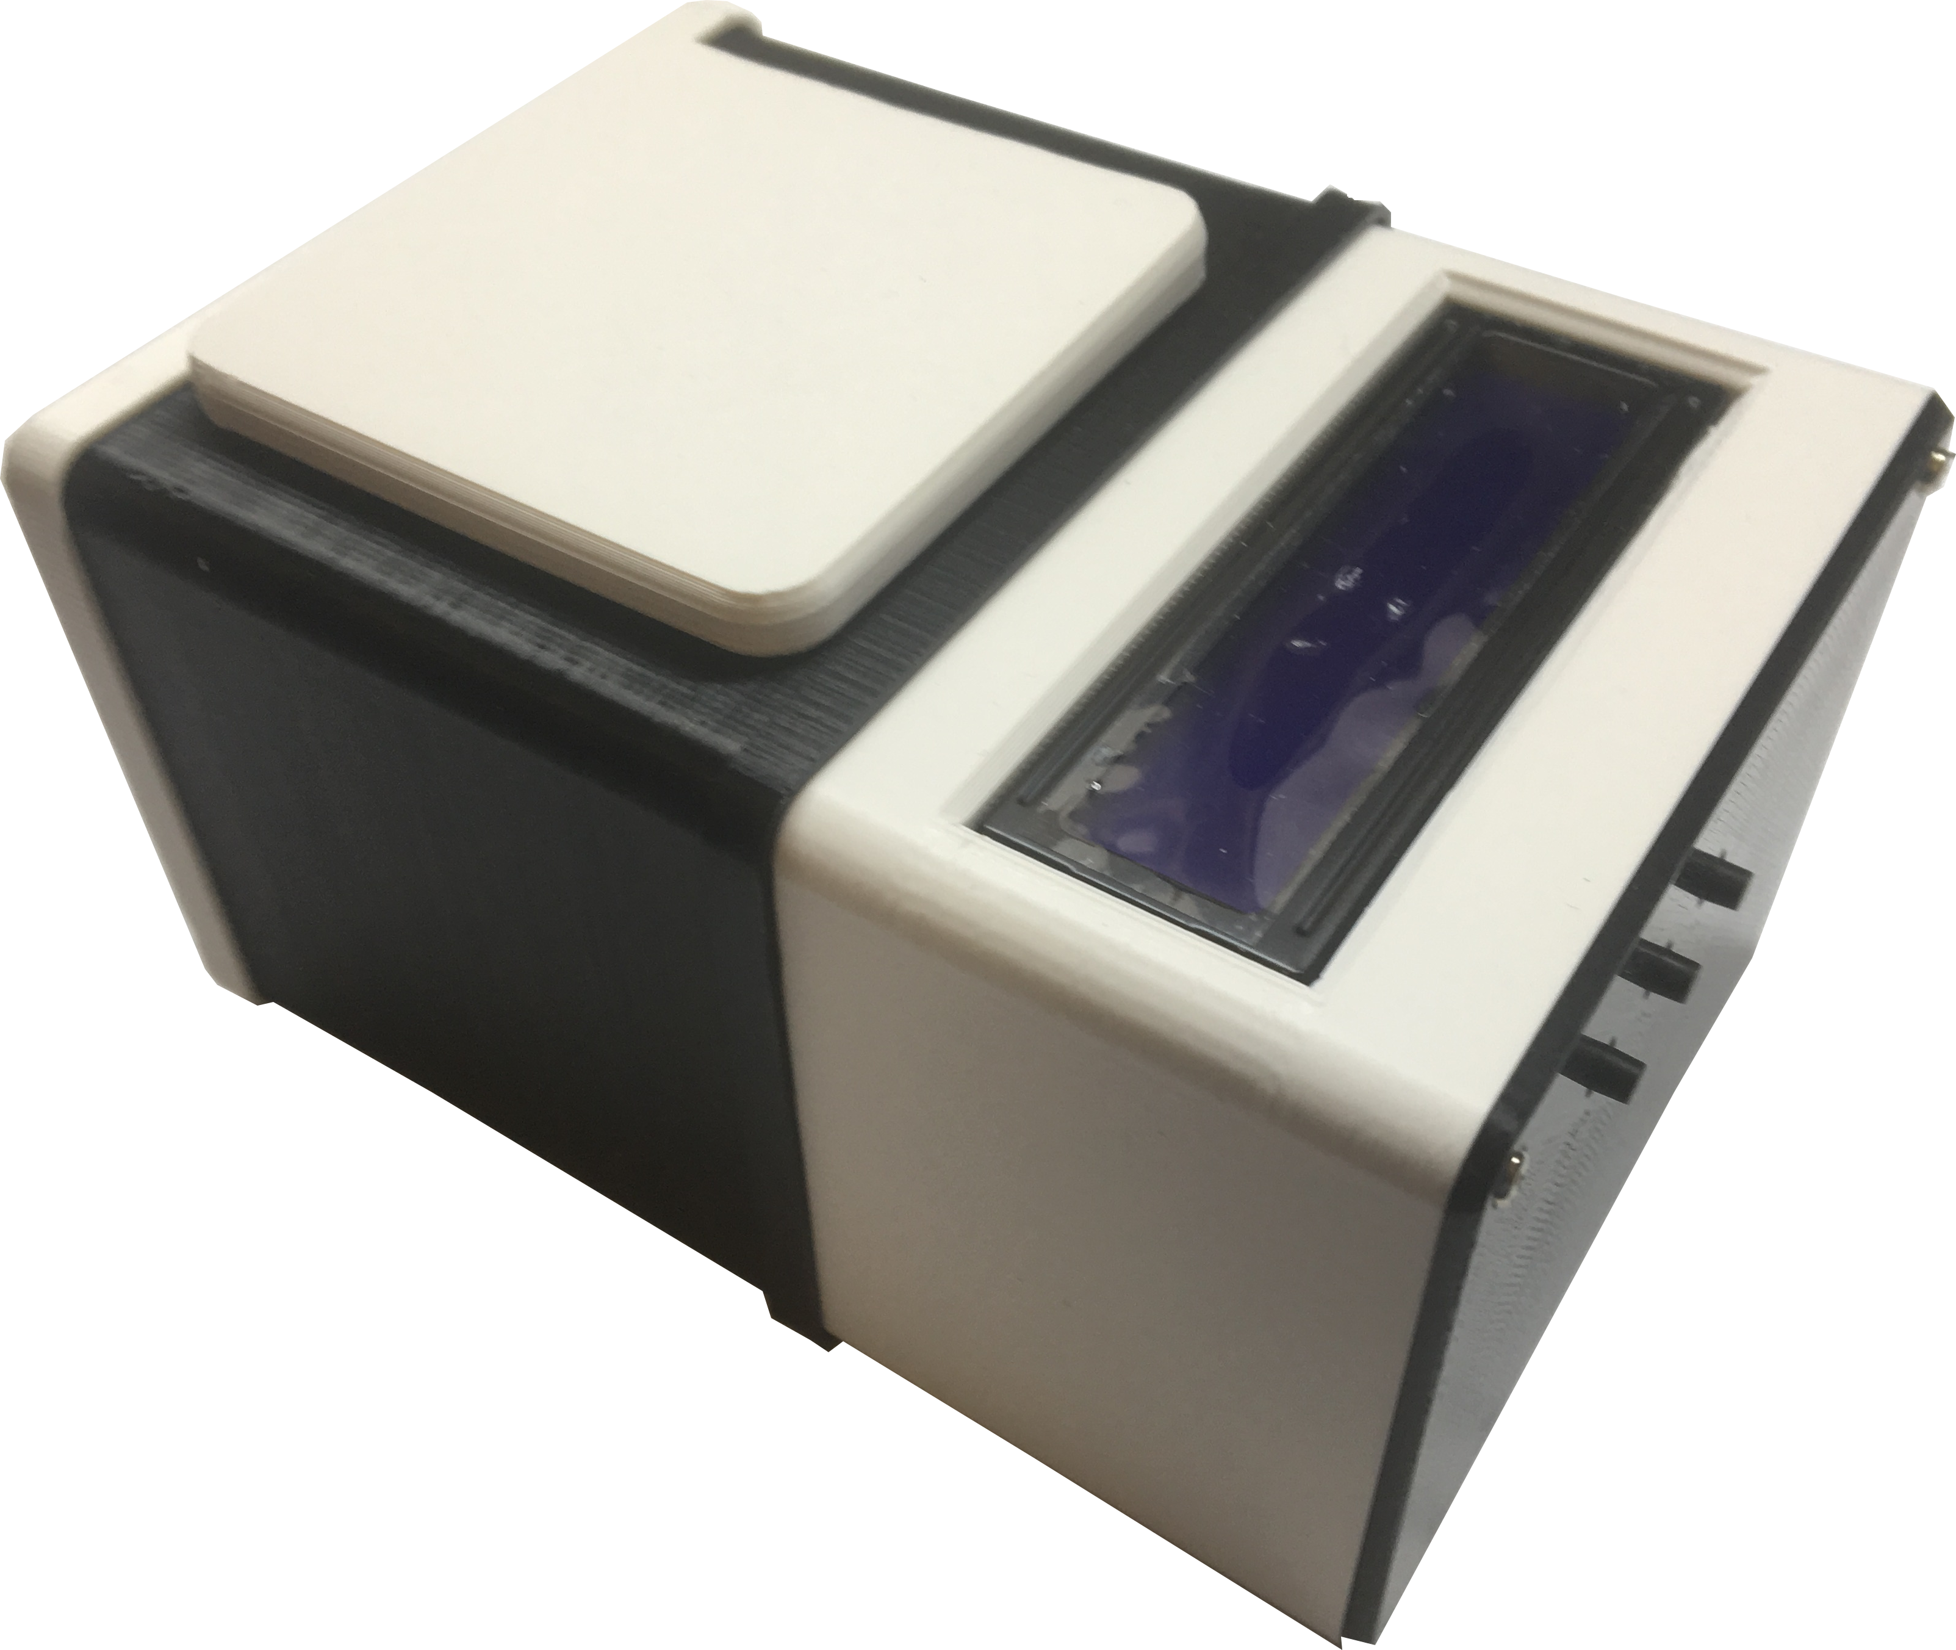

www.diyorbuy.tech

## Introduction

## Thank you for choosing our feeder. We are constantly improving our products and we hope that they will benefit you and meet your expectations.

## Equipment

You will find in the box:

1. The feeder.
2. The cover for the food section.
3. Power cable.

**Preparation for use**

Prepare the installation site on your aquarium. If necessary, make the hole in the cover of aquarium. The location of installation should have sufficient surface for the feeder installation. The feeder body can't be hanging over the water more than 1 cm. Do not place the feeder on curved surfaces. Place the feeder on the aquarium. Connect the power cable first to the feeder, then to the power supply. Plug the power supply into an outlet. Screen feeder should turn on and it shows "I'm DOMOVOY!" and current time.

**Feed loading**

Slide the feeder cover. Pour food into the feeder. Slide the cover back until it stops.

## Buttons

The feeder has 3 buttons. The left button is used to select programming modes. The middle button changes the clock when you set the time. The right button sets the minutes.

## Clock set

To set the time, press the left button twice. The first press of the button will turn the display on. The second press will transfer the feeder to the time setting mode. Press or hold the middle button until the desired hour is displayed. Press and hold the right button to set the minutes. After setting the time, press the left button 6 times to return to the home screen.

**Set the feeding time**

The feeder can be programmed up to four feedings per day. Feeding is activated if it is set to a time other than 00:00. Setting the feeding time at 00:00 disables it.

To set the 1st feeding time, press the left button 3 times. Set the hour with the middle button, minutes-right. Press the left button 5 times to return to the home screen.

Other feeding periods are set similarly. By pressing the left button, you can move from one feeding to another.

**Feed dosage setting**

Press the left button 7 times to enter the feeding dosage setting mode. To set the correct dosage, we recommend you to set the initial value of 10 units and carry out manual feeding (will be described below) to determine the amount of feed poured out by the feeder. After that, set the dosage in proportion to the amount of feed required.

**Manual feeding**

You can manually initiate feeding mode at any time. To do this, press the middle and right buttons simultaneously.

**Important note**

The feeder is designed to feed dry bulk feed. Before you begin, make sure that the size of the feed pellets allows them to move freely while rotating the auger and pass through the opening of the feed case.

When feeding the auger trough first rotates in the reverse direction for a few revolutions, then rotates, feeding the food into the aquarium. At the end of the feeding auger again makes a few turns back. The algorithm of rotation of the auger allows to avoid sticking and wetting of the feed.

Feeding modes and feed dosage are not lost when power is turned off.

To clean the feeder, use a brush. Do not rinse the feeder under water.

**Mobile application**

If your phone is running Android OSб to control the feeder you can use the mobile app. You can download it using this QR code



**Caution**

Remember that the feeder is connected to a high voltage power supply. This voltage is dangerous for life!

Do not allow the feeder to fall into the water.

Do not touch the power supply with wet hands.

## When disconnecting the feeder, first unplug the power supply, then disconnect the power cable from the feeder.

## Contacts

For all questions, you can contact by email: [z@mf21.ru](mailto:z@mf21.ru);

Technical development center «SISTEMA»

[www.](http://www.)diyorbuy.tech